**Zetta Menu**

|  |  |
| --- | --- |
| Autor  <https://codecanyon.net/user/_nk/portfolio>  **Support**  Si necesita ayuda, todo el apoyo se llevará a cabo a través de esta página web –  [https://nk.ticksy.com](https://nk.ticksy.com/). |  |

Zeta Menu se divide en 3 Presentaciones:

[**http://cc.nkdev.info/zettaMenu/**](http://cc.nkdev.info/zettaMenu/) **(CSS3) ---** Puro css[**http://cc.nkdev.info/zettaMenuJS/**](http://cc.nkdev.info/zettaMenuJS/) **(jQuery) ----** Usando jquery[**http://cc.nkdev.info/ZMenuMaker/**](http://cc.nkdev.info/ZMenuMaker/) **(Menu Maker) ----** este tiene su propio constructor

**Buscando en** [**https://codecanyon.net/search?utf8=%E2%9C%93&term=Zetta+Menu**](https://codecanyon.net/search?utf8=%E2%9C%93&term=Zetta+Menu)

**Zetta Menu - jQuery Mega Menu (v1.1)**

**Zetta Menu** is jQuery **mega menu** plugin. Regular License $7

<https://codecanyon.net/item/zetta-menu-jquery-mega-menu/7941407?s_rank=1>

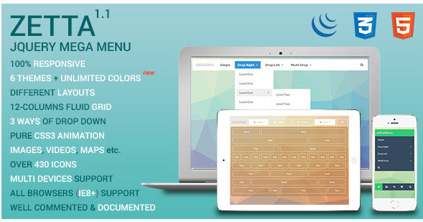

**Zetta Menu - CSS3 Mega Menu and Drop Down menú (v1.3)**

**Zetta Menu** is pure CSS3 **mega dropdown menu**. Regular License $6

<https://codecanyon.net/item/zetta-menu-css3-mega-menu-and-drop-down-menu/7667949>

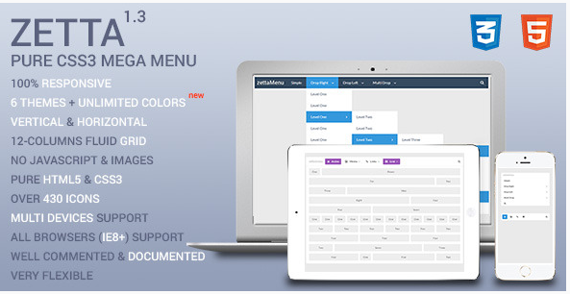

# **Z Menu Maker - Drop Down and Mega Menu**

# **Z Menu Maker - es un fabricante de menú visual sin la codificación. Creación de un menú que desea, nunca ha sido tan fácil. Comience con 7 aspectos predefinidos y hacer su propio** Regular License $11

**.**<https://codecanyon.net/item/z-menu-maker-drop-down-and-mega-menu/9240528>

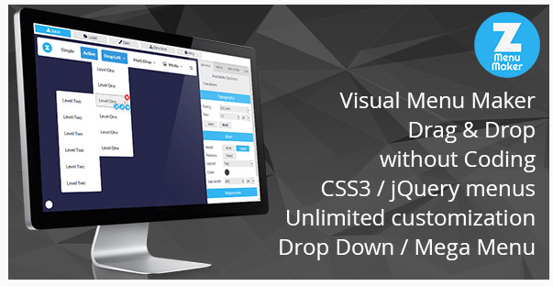

**otros**

<http://www.codelist.cc/scripts/>

<http://preview.codecanyon.net/item/css3-responsive-mega-drop-down-menu/full_screen_preview/10690936?_ga=1.98515743.1698295773.1470757751>

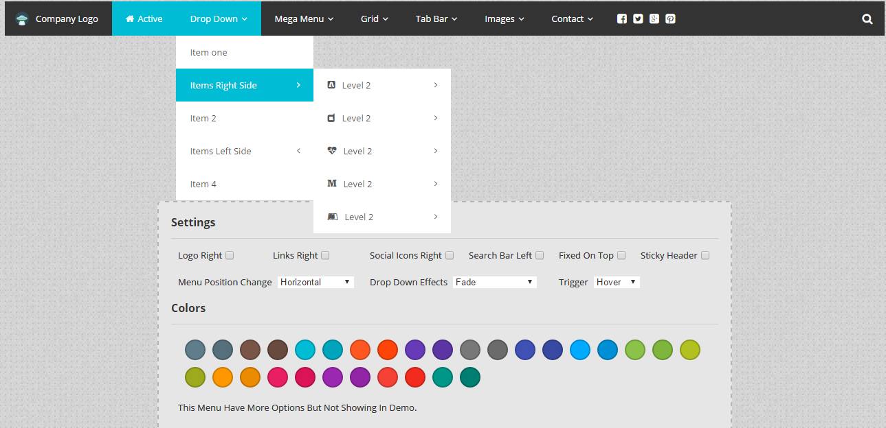

<http://preview.codecanyon.net/item/responsive-multi-level-accordion-liaccordion/full_screen_preview/13588181?_ga=1.195975980.1698295773.1470757751>

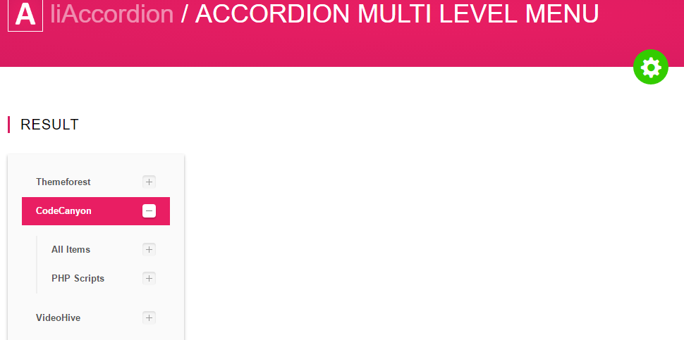

# Duramenu | Responsive Bootstrap Menu

<http://www.codelist.cc/scripts/1083-sitespy-v31-complete-visitor-seo-analytics.html>

[**https://codecanyon.net/item/duramenu-responsive-bootstrap-menu/17177553?s_rank=1**](https://codecanyon.net/item/duramenu-responsive-bootstrap-menu/17177553?s_rank=1)

[**http://preview.codecanyon.net/item/duramenu-responsive-bootstrap-menu/full_screen_preview/17177553?_ga=1.240531587.1698295773.1470757751**](http://preview.codecanyon.net/item/duramenu-responsive-bootstrap-menu/full_screen_preview/17177553?_ga=1.240531587.1698295773.1470757751)

<http://www.estudiosurestao.com/blog/menu-responsive-sencillo/>

https://codecanyon.net/item/sky-mega-menu/5136673?s_rank=99

plantillas

<http://www.elegantthemes.com/gallery/>